Angleščina, 5. razred
Doma se temeljito pripravljajte na pisno ocenjevanje, ki bo sledilo po prihodu v šolo.
Naredite pa še naslednje naloge, in sicer v 5. tematskem sklopu:
- Učbenik str. 56 prepišite nov naslov MY DAY in prepišite besedišče prve naloge.
- Nato napiši naslov WHAT'S THE TIME? In poslušaj razlago na spodnji povezavi
- https://www.youtube.com/watch?v=fq2tRfHu5s8
- nato pa si prerišite in prepišite sledeče:
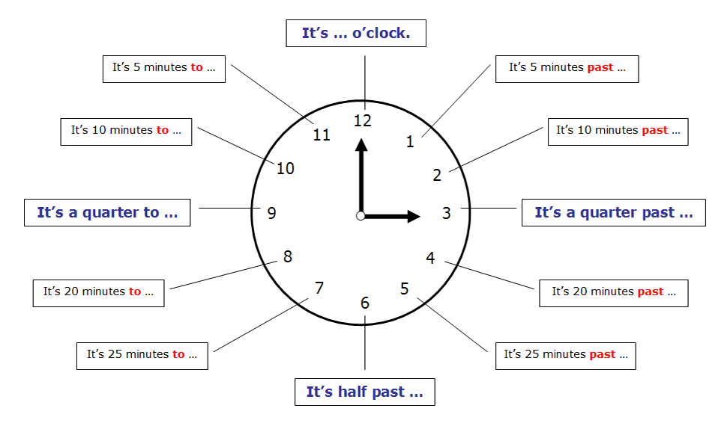

How to tell the time in English
a.m. - p.m.
a.m. = ante meridiem = the time from midnight to noon = from 00:00 to 12:00
p.m. = post meridiem = the time from noon to midnight = from 12:00 to 24:00

Examples:
11:00 | 11 a.m. | It's eleven o'clock a.m. | 08:15 | 8:15 a.m. | It's a quarter past eight a.m.
23:00 | 11 p.m. | It's eleven o'clock p.m. | 20:15 | 8:15 p.m. | It's a quarter past eight p.m.
10:30 | 10.30 a.m. | It's half past ten a.m. | 09:10 | 9:10 a.m. | It's ten (minutes) past nine a.m.
22:30 | 10:30 p.m. | It's half past ten p.m. | 11:20 | 11:20 a.m. | It' twenty (minutes) past eleven a.m.
04:45 | 4:45 a.m. | It's a quarter to five a.m. | 21:50 | 9:50 p.m. | It's ten (minutes) to ten p.m.
16:45 | 4:45 p.m. | It's a quarter to five p.m. | 19:40 | 7:40 p.m. | It's twenty (minutes) to eight p.m.

- Asking for the time
- There are two questions to ask for the time: What's the time? or What time is it?
- V učbeniku na str. 58 preberite zgodbo GRANDAD in izpišite neznane besed. Nato pa v zvezek prepišite pesmico MR Upside- Down, str. 59.
- Nato pa v učbeniku na str. 61 preberite TIME ZONES in rešite 2. nalogo v zvezek.
- V DZ rešite naloge od str. 46 – 51. (razen slušnih)

Učiteljice angleščine

